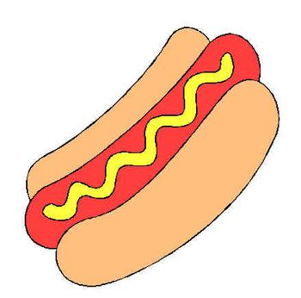

Hot Dog Eating Contest

Sponsored by:

CONTEST RULES

- Entries will be limited to the first 15 contestants. Forms can be mailed beginning on Monday, July 1st – first come, first serve type basis.
- Contestants must be at least 16 years of age.
- All contestants must be registered, checked in by 11:00 am on Saturday, August 25th .
- The object is to eat as many hot dogs and buns with water as the only beverage. Water will be provided to all contestants.
- Each contestant will be given ten hot dogs to start.
- Contestants will wait for the signal to start and a stopwatch will be used.
- The allotted time is five (5) minutes.
- Dunking and crunching the hot dog and bun is allowed.
- Separating the hot dog and bun to eat them individually is allowed.
- Contestants must not touch any hot dogs until the starting signal.
- Winner will be determined by whomever has eaten the most hotdogs within the allotted time. (must finish what is put in your mouth when the time ends)
- The judges will determine the winner of the contest not the participants & the judges’ decision will be final.
- Any contestant caught breaking any of the above rules will be disqualified.

First Name: Last Name:

Address:

Phone: Email: _____________________________

Date of Birth______________________________ Age_________

Emergency Contact: Relationship:

Emergency Contact Phone Number______________________

WAIVER

I know that eating large amounts of hot dogs is potentially hazardous and is an uncomfortable activity. I should not enter and eat unless I am medically capable and properly trained. I realize that this is in good fun and possibly bad taste, but I agree to be a good sport. I agree to abide by any decision of the contest officials and all the contest rules. I assume all risks associated with eating in this type of event including but not limited to indigestion, that stuffed feeling, contact with other contestants, and a general dislike for hot dogs after I am done, and all such risks being known and appreciated by me. Having read this waiver and knowing these facts and in consideration of you accepting my entry, I, for myself and anyone entitled to act on my behalf, waive and release the Randolph County Fair, their representatives, sponsors, and their successors from all claims of liabilities of any kind arising out of my participation in this event.

Contestant Signature: _____________________________________Date:__________________________

Parent/Guardian Signature:__________________________________________
(If contestant is under 18 years of age)

